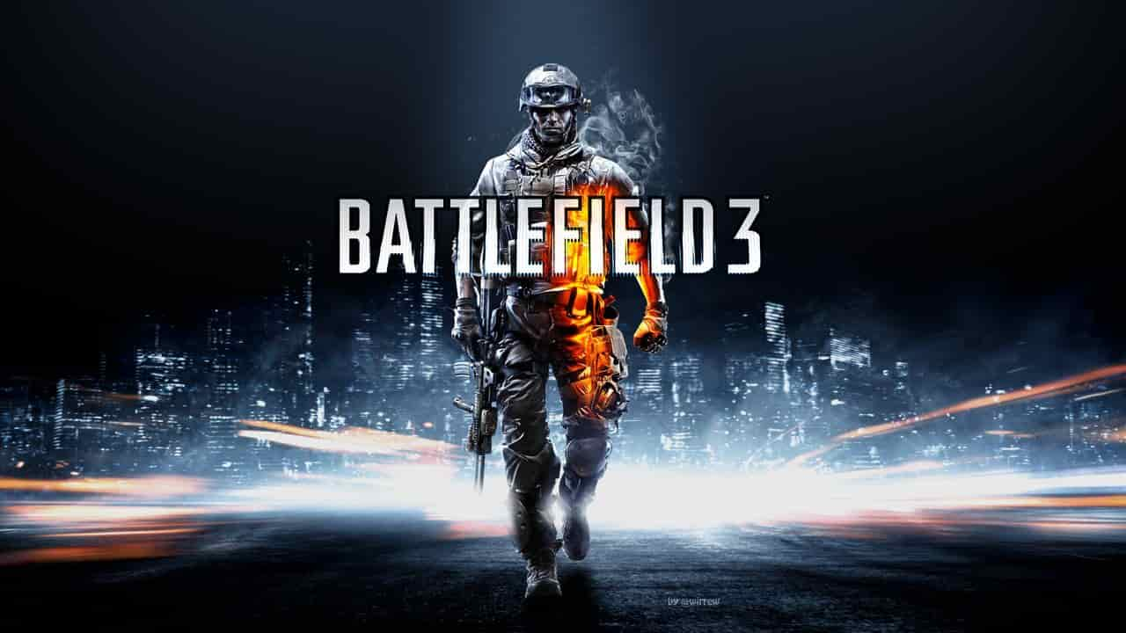

**BATTLEFIELD 3**

**Developed By:** [DICE](https://www.google.com/search?sxsrf=AOaemvK1L37Y8cLXUCbPHY-zmDq4siTBcg:1640621345596&q=EA+DICE&stick=H4sIAAAAAAAAAOPgE-LSz9U3MK40SC8pV-IEsY3STcuMtFSyk630k8vS9ZPzcwtKS1KL4ssyU1Lz0xNzU61SUstSc_ILUosWsbK7Oiq4eDq77mBlBACqc4WYTAAAAA&sa=X&ved=2ahUKEwia747kroT1AhX2RfEDHWcUDj0QmxMoAXoECEcQAw&cshid=1640621506567093)

**Description:** Battlefield 3 is a 2011 first-person shooter video game developed by DICE and published by Electronic Arts for Microsoft Windows, PlayStation 3 and Xbox 360. It is a direct sequel to 2005's Battlefield 2, and the seventh main installment in the Battlefield franchise

**Platforms:** PlayStation 3, Xbox 360, Microsoft Windows

**System Requirement:**

* A minimum computer system that will help you access all the tools in the courses is a Pentium 166 or better.
* 64 Megabytes of RAM or better.

**Published By:**

